What is polymorphism and why is it important?
- Explain the meaning of Polymorphism:
  - Polymorphism is the ability to re-utilize the same functional call in a base class to complete a different function. Each individual linked call will be able to adapt and utilize the top-level function and complete an alternative goal
- Highlight a benefit of Polymorphism:
  - This makes it possible for the application designer to apply different rules to a sub function and thereby cause an improved execution matrix to complete.
  - This can simplify the overall functionality of your application.
- Provide an application of Polymorphism:
  - An example would be to have a functional call perform an update and return a different result depending on how the data was defined.
  - This would allow you to store different types of information is a list and then provide a method of using the same function to do different actions depending on what the contents of the stored information were set to explore.
- Show a coding example of Polymorphism from the program you wrote.
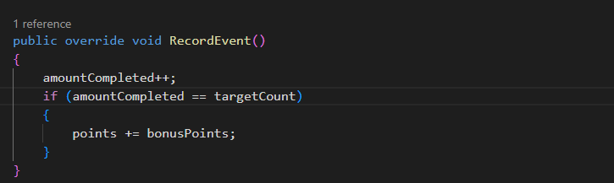
- To me, the ability to re-utilize the ‘RecordEvent()’ as shown above in multiple elements of your application provides a strong example of being able to overcome similar functions without having to re-design and re-build the common code base. When this happens, it simplifies the ability of maintaining your code and allows you to use it and keep your code smaller in overall scope.
  - When I was working at Martin Marietta, I had to re-use a lot of code in my ‘Comet’ application which grew to over 200,00 lines of code. Lots of re-entrant code examples, but since it was a script based application, it became very un-friendly for maintenance. I had done a thorough implementation of commenting the applications so that it was not difficult to follow the overall scope, but if I had not done the commenting, it would have been a real nightmare.

